1.PHYSICAL PRINCIPLES OF METALS STRENGTHENING
1.1.Role of dislocations theory.
The expediency of either metals strengthening may be adjusted only after understanding of physical bases of the last ones.
Most of the important properties of metallic materials are determined by their structure, the structure means not only microstructure (grains, the second phase particles), but fine structure - dislocation and disclination structure. The small changing in the fine structure causes the sharp changing of the properties.
One of the most important structure sensitive properties of advanced metallic materials are mechanical properties.
The last ones determine the strength and fracture under different character of loading.
In the present time it is found that physical nature of the plastic deformation and fracture is described by the dislocation and disclination theories [1-4]. According to the formulated and experimental facts corroborated the last theories it is follows that the dislocations motion is responsible for the deformation. It is possible to increase the plastic retardation of dislocation strength as a result of attacks to the metal structure.
There are four main retardation of dislocation mechanisms[5]:
- formation of alloying elements atoms jam or segregations or vacancies around the dislocations in the solid solution;
- the upgrading of the dislocations density result in the intensification of them, moving dislocations when the stress interaction between zone around ones is disturb to the other ones;
- the formation of the barriers for the moving dislocations as a division surfaces (the different type boundaries) in crystals or the second strengthening phase particles - i.e. the creation of the volumes with different slipping of dislocations crystallography inside of the alloy;
- the generation of the ordering (with respect to the composition or crystallographical orientations) of atomic configurations; under dislocation motion through the last ones it necessary to expend part of the dislocation energy to the ordering - disordering processes performance result in the dislocations retardation.
It would seem using so wide retardation dislocations methods it is possible to create such structural state in metallic materials wherein the dislocations mobility under high loading will sharply decreased and the strength increased significantly. But an engineering comprehension of the structural materials strengthening means not only possibility to increase the external loadings without appreciable macroplastic deformation in the given part, but the absence under the designated operation conditions, characterized by the variety of stresses schemes and temperature - rate loading parameters, sudden (premature) destruction. The last ones it is most likely in those cases, when the combined margin of plasticity and toughness metallic materials have lowered, and the relaxation of rise during loading awkward stresses by means of deformation transfer in the neighboring volumes is impeded.

The relation between dislocation density and the stress

With the development of the transmission electron microscope technique, it has been possible to make direct studies of the dislocation structure in deformed metals. These investigations have indicated that for a very wide range of metals there exists a rather simple relationship between the dislocation density and the flow-stress of a metal. Thus, let us assume that Fig.1.1 represents the general shape of the stress-strain curve of a metal and that a series of specimens are deformed to different strains, as indicated by the marked points along the curve.
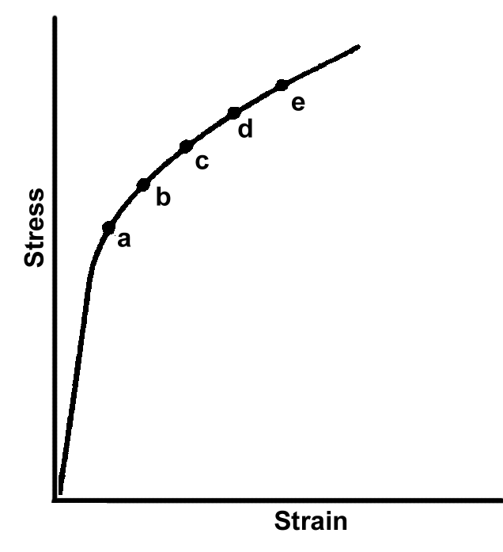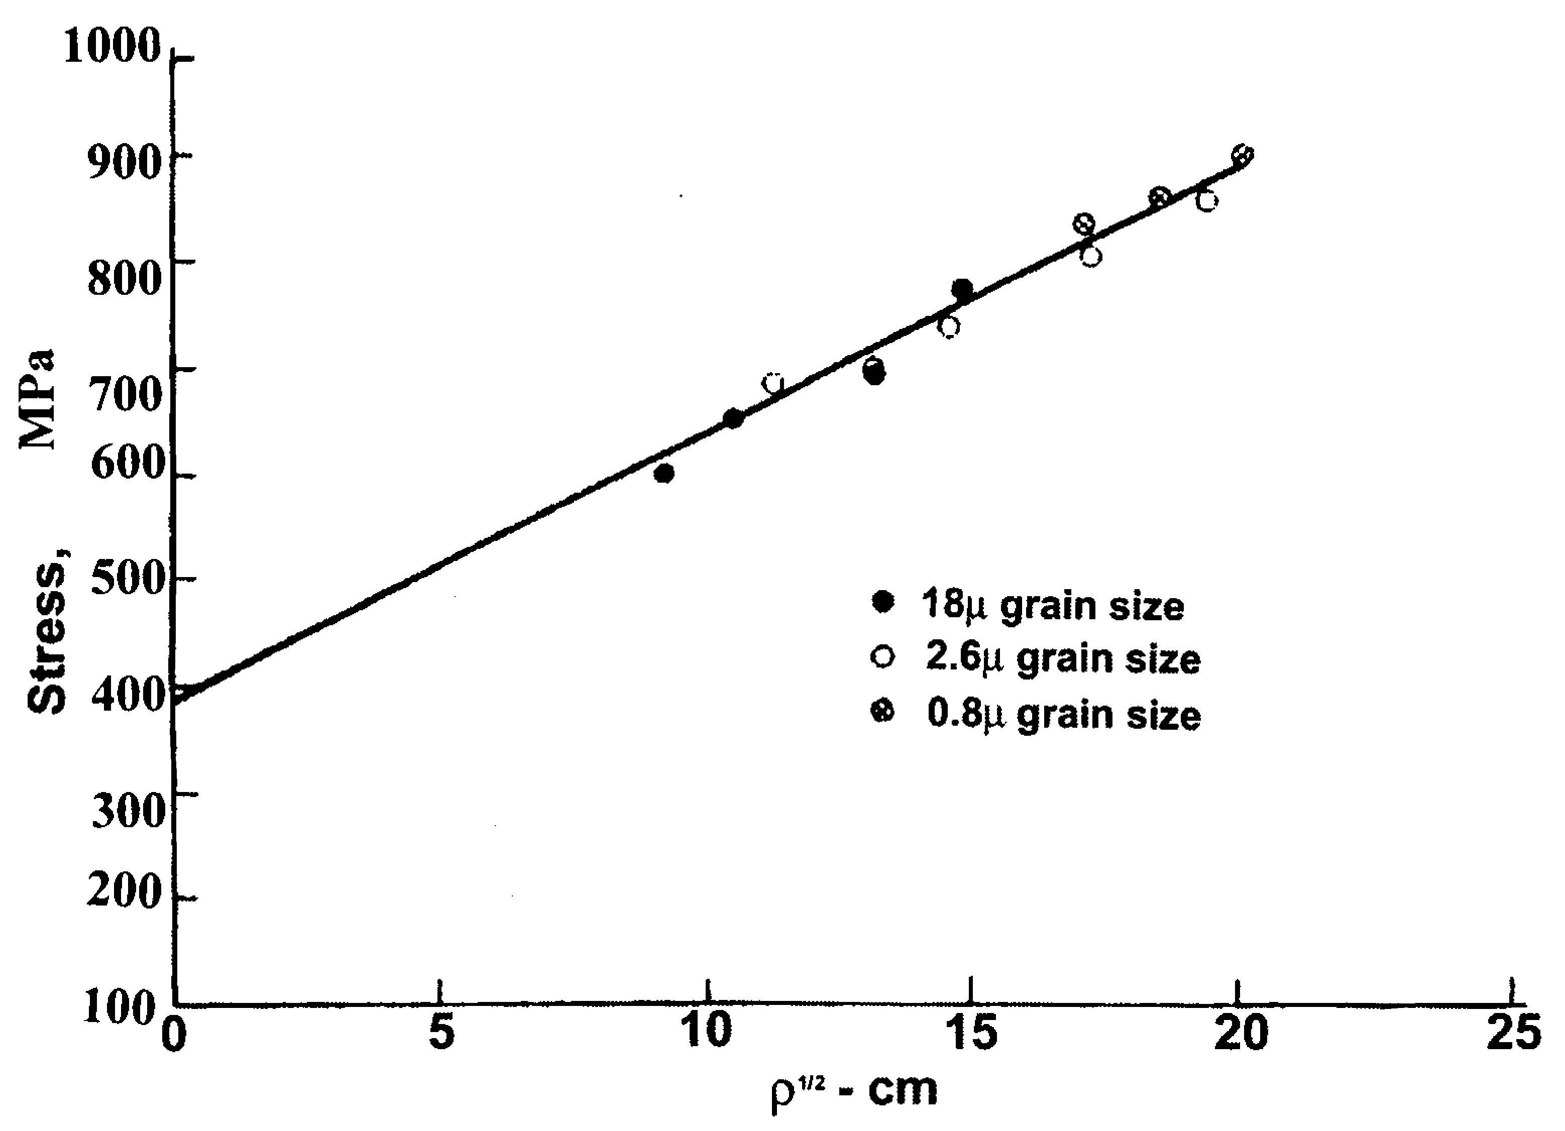  Fig.1.1. General shape of the stress-strain curve of a metal | Fig.1.2. The variation of the flow-stress σ with the square root of the dislocation density ρ^{1/2} for titanium specimens deformed at room temperature and at a strain rate of 10⁻⁴ s⁻¹ .
To determine the variation of the dislocation density with strain during a tensile test, a set of tensile specimens are strained to a number of different positions along the stress-strain curve, such as points a to f in this diagram. These specimens are then sectioned to obtain transmission electron microscope foils.
Furthermore, let us assume that on reaching the specified strains, they are unloaded, sectioned for observation in the electron microscope, and that dislocation density measurements are made on the foils. Fig.1.2 shows the actual experimental results obtained using a set of titanium specimens. This data corresponds to specimens of three different sizes. Note that all of the data plots on the same straight line. Data such as this supports the assumption that the stress varies directly as the square root of the dislocation density, or
1.1

where ρ is the measured dislocation density in centimeters of dislocation per unit volume, k is a constant, and σ₀ is the stress obtained when ρ^{1/2} is extrapolated to zero. This result is good evidence that the work hardening in metals is directly associated with the build-up of the dislocation density in the metal. While the above relationship to data from polycrystalline specimens, the relationship has also been observed in single-crystal specimens. In this case, it is more proper to express the relationship in permits of the resolved stress on the active slip plane τ.
This gives us
1.2
where τ₀ is the extrapolated shear stress corresponding to a zero dislocation density. Actually, if the dislocation density were zero, then the metal could not be deformed. As a consequence, σ₀ or τ₀ are best considered as convenient constants rather than as simple physical properties.
Taylor’s relation
In 1934, Taylor [7] proposed a theoretical relationship that is basically equivalent to the experimentally observed functional relationship between the flow stress and the dislocation density. In the model that he used, it was assumed that all the dislocations moved on parallel slip planes and the dislocations were parallel to each other. This model has since been elaborated by Seeger [8] and his collaborators. In brief, this approach assumes that if the dislocation density is expressed in numbers of dislocations intersecting a unit area, then the average distance between dislocations is proportional to ρ^{1/2} . The stress field of a dislocation varies as 1/r, or in general we may write
1.3
where μ is the shear modulus, b is the Burgers vector, and r is the distance from the dislocation. Now consider two edge dislocations on parallel slip planes. If they are of the same sign, they will exert a repulsive force on each other. If they are of opposite sign, the force will be attractive. In either case, this interaction must be overcome in order to allow the dislocations to continue to glide on their respective slip planes. Since, as shows above, the average distance between dislocations is proportional to ρ^{1/2}, we have
τ = αμbρ^{1/2} 1.4
or
τ = kρ^{1/2} 1.5
where k is a constant of proportionality equal to αμb.

