*BUSINESS ENGLISH*

*Unit one*

Meeting an English businessman

Text

David Hill, an English businessman, is at Sheremetievo airport in Moscow. Pete and Nick, Russian businessmen, are at the air­port to meet Mr. Hill.

*Pete:* Hello, Mr. Hill!

*David:* Hello, Pete! It is so good to see you! Thank you for meeting me.

*Pete:* I am very glad to see you too. Can I introduce my friend and colleague Nick?

*David:* How do you do, Nick?

*Nick:* How do you do, David? I'm glad to meet you.

And they shake hands. In Britain most people shake hands when they meet someone for the first time. It is not usual to shake hands when you say good-bye or when you meet again later.

*Pete:* Follow me please, David. Watch the step!Our car is in the parking area.

*Unit two*

Speak with Englishmen!

**Text**

Pete, Nick and David are in the car. They are going to the centre of Moscow.

*Pete:* Did you have a good trip, Mr. Hill?

*David:*Oh**,** yes. The flight was quite smooth. And I'm very glad the plane came on time.

*Pete:* And how do you like so much snow around?

*David:* Oh, I like Russian winter. Our winter is different. It's much milder. Have you ever been to England, Nick?

*Nick:* Will you repeat it, please? My English is not good enough, I am afraid.

*David:* Have you been to London?

*Nick:* No, not yet. But I am planning to go to England in summer.

*David:* As a tourist?

*Nick:* I think so.

*Pete:* And here is the hotel... Let me help you with the suit case, David.

*David:* Thank you. That's very kind of you.

*D.:* Thank you. That's...

*Unit three*

The Russia hotel

**Text**

The car has brought Pete, Nick and David to the Russia hotel. Now they are in the lounge of the hotel.

*Pete:* Just a minute, David. I'll speak to the receptionist. We made a reservation last week... Will you fill in this form, please?

David fills in the form, comes up to the receptionist and hands in the form.

*David:* Here you are. Is everything all right?

*Receptionist: ...* Yes, everything is OK... Your room number is five о two. Here is your key.

*David:* Thank you.

*Receptionist:* You are welcome. Have a nice stay.

*David:* Thanks.

*Pete:* David, will you join us for dinner to-night?

*David:* I'll be glad to.

*Pete:* Fine. Then we'll meet you here at seven sharp. And, if you don't mind. we shall have dinner at the hotel restaurant. It's not bad at all.

*David:* Thank you for the invitation. See you later.

*Unit four*

At the restaurant

**Text**

It is seven sharp. Pete and David are in the lounge.

*Pete:* Good evening, David.

*David:* Good evening, Pete.

It is two minutes past seven. They see Nick.

*Nick:* Good evening. I'm late, I'm afraid. I do apologise.

*David: Good* evening. That's all right.

*Pete:* Good evening. Follow me please, gentlemen.

They go to the restaurant. The head waiter comes up to them and offers them one of the vacant tables.

*Pete:* Do you like this table, David?

*David:* It looks all right.

*Pete:* Then let's take it... Here is the menu...

*David:* Oh, it's in English too. How very nice.

*Pete:* What would you like to drink?

*David:* Gin and tonic for me, please.

*Nick:* And what would you like as a starter?

*David:* Your English is very good. Some cold fish, I think.

*Nick:* Thank you for the compliment. I'll tell my teacher about it. And what would you like as a hot meal?

*David:* Some meat and vegetables.

*Pete:* And here are our drinks... I'm very glad to see you in Moscow, David. I still remember my Christmas days in London. Now you are welcome to Moscow. To our good business!

*David:* I do hope our business will be beneficial for all of us.

*Unit five*

Small talk

**Text**

Pete, Nick and David are still at the restaurant. They are enjoying their meal and have a small talk.

*Pete:* David, is this your first visit to Moscow?

*David:* Oh, no. 1 was in Moscow last year. I like your city very much. It's a pity my sister is not with me now. She wanted to go so much.

*Nick:* And why didn't she join you? Is she busy?

*David:* Well, you see, she could not leave her office, her boss did not let her go. They are working at a very important proj­ect now. And have you got a sister or a brother, Nick?

*Nick:* Oh, yes. I have a brother. He is on holiday in the mountains.

*Pete:* Oh, really? My elder daughter is also in the mountains in Chechia now. She is fond of skiing and goes to the mountains every winter.

*David:* Have you got a big family?

*Pete:* I wouldn't say so. There are five of us. Two daughters, a son, my wife and I.

*David:* Quite an English family!

*Unit six*

Making an appointment

**Text**

The three gentlemen have enjoyed their dinner and they are pre­paring to leave the restaurant:

*Pete:* Thank you for the nice evening, David.

*David:* Likewise. I enjoyed everything very much. And I liked the orchestra. I like Russian music immensely.

*Pete:* Very often they play English songs here. They sound su­ perb.

*David:* Then I was lucky to listen to Russian songs tonight. They are more than beautiful....

The waiter comes up to Pete and hands the bill over to him.

*David:* Oh, let me pay the bill, Pete.

*Pete:* Oh, no. It will be my pleasure... And when can you come to our office tomorrow?

*David:* Will ten o'clock be convenient to you?

*Pete:* Fine. Then Nick will pick you up tomorrow at ten to ten in the lounge.

*David:* OK. See you tomorrow then.

*Nick:* Good-bye. See you tomorrow. I won't be late I promise.

*David:* I hope I won't be late either.

*Pete:* Have a good sleep. See you tomorrow.

Unit seven

Business

**Text**

The next day at exactly nine o'clock Pete comes to his office. He knows that he should refresh the correspondence with David and prepare for the talks he will have with David at ten. First he starts looking through all the letters and faxes of Mr. Hill.

*Here is the the recent fax message of Mr. Hill:*

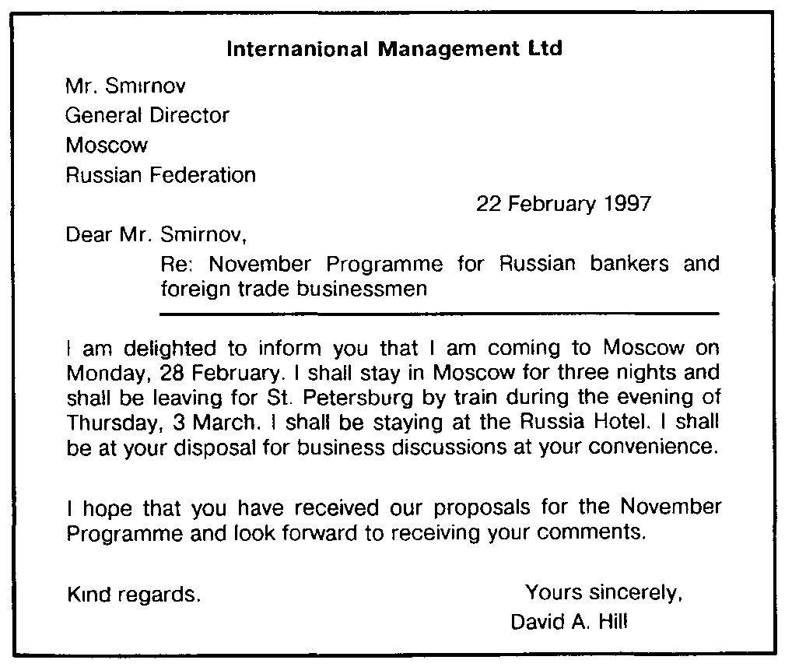

Then Pete looks through the letters of the participants of the Pro­gramme expressing their wishes and requests. He makes a note that he should discuss the following details with Mr. Hill:

• time

• hotel accommodation

• topics to be discusssed at the lectures

• business visits

• programme fee

A business talk

**Text**

At exactly ten to ten Nick enters the Russia hotel and sees David in the lounge. They exchange gleetings and go to the car. A few minutes later they come to Pete's office. Now they are entering the office:

*Pete:* Good morning, David. I hope you had a good sleep and liked the hotel.

*David:* Thank you. The hotel and the restaurant are all right. We had a very nice evening at the restaurant. Everything was fine.

*Pete:* I also enjoyed last night. Now, shall we get down to business?

*David:* Yes, certainly. There are a few points to discuss. What would you like to start with?

*Pete:* If you don't mind, let's start with the time of the Pro­gramme. We are planning to send a group of ten per­sons not later than on the 10th of November.

*David:* How long will they stay?

*Pete:* They prefer to be in London for eight days or seven nights.

*David:* Good. Have you got any comments on the topics of the lectures?

*Pete:* On the whole the participants are quite satisfied with your choice. But if you could add "Accounting in com­panies and banks" it will be very good.

*David:* No problem. I'm making a note of that. We have got a very good lecturer.

*Pete:* And where will the lectures be read?

*David:* In one of the conference rooms of the hotel, where they will stay. I mean the Sherlock Holmes Hotel in Baker Street.

*Pete:* I hope it is in the centre of London.

*David:* Oh yes. It is very close to Oxford Street and Madam Tussaud's.

*Pete:* Very good. Then let's make a break for lunch.

*David:* Not a bad idea!

Unit nine

Details

**Text**

After having lunch at the canteen of the company the business­men resume their talk.

*Pete:* There a few more things I would like to discuss with you.

*David:* Well, I'm at your service, sir.

*Pete:* In your offer you proposed a few external business visits for the group.

*David:* Yes, I proposed visits to the Bank of England, Metal Exchange, a lawyers' company and a small producing company.

*Pete:* That's right. Could you cut a visit to the Metal Ex­change? A few participants would like to have some time for a visit or two of their own interest.

*David:* Good. We shall have lectures in the moinings and busi­ness visits in the afternoons. Two afternoons are free. And the participants may easily pay their own visits. If they need my help I am always very glad to help.

*Pete:* Fine It's settled then And one more thing. What cultural excursions will the group make?

*David:* I propose visits to Windsor and Oxford.

*Pete:* Fine. Now comes the most important question. I mean the Programme fee.

*David:* Let me make some calculations first ... Taking into con­sideration all the changes we made in the programme the fee comes to ten thousand pounds.

*Pete:* In other words one thousand per person... I suppose I can agree to that. It seems to me we have discussed all the points and can sign a Contract.

*David:* When we meet tomorrow afternoon the Contract will be ready and we shall sign *it*.

*Pete:* See you at 3, if it is convenient for you.

*David:* Good. See you tomorrow then. Good-bye.

**Text**

The next day the businessmen meet at Mr. Smirnov's premises and Mr. Hill hands him over a copy of the Contract he has prepared.

*Here is a part of the Contract.*

**International Management Ltd**

Contract dated 2 March,199. .

This Contact is made between:

*International Management Ltd,* London, United Kingdom, herein­after referred to as Organiser and *Economtraining*, Moscow, Russian Federation, hereinafter referred to as Customer.

This Contract concerns the Programme for a Group of 10 senior bankers and foreign trade company executives (the Participants) from the Russian Federation as nominated by the Customer, scheduled to take place in London during 8 days in November, 199. .. The exact dates are to be specified before 20 October.

Both parties to this Contract are bound by the terms and condi­tions of the Contract as set out below.

**Article 3. Undertakings by the Organiser**

• The Organiser shall provide Business Skills Courses during the Programme which shall collectively amount to not less than 15 hours of intensive classroom tuition, to be divided into 15 classroom "Sessions". Classroom Sessions shall take place on Training Days (Monday through Friday).

• The Organiser shall provide professional trainers to teach the Business Skills Courses who shall have appropriate professional and/ or academic experience and expertise.

• The Organiser shall provide an appropriate conference room at the Hotel in which the Business Skills Courses shall be conducted.

After Pete studied the Contract carefully, the businessmen sign two copies, one for each party.

Then Pete invites David to celebrate the event at the restaurant in the evening. The next day David leaves Moscow for St. Petersburg.

*Unit eleven*

Fax messages

**Text**

On 15 October after booking airtickets for the Participants Pete sends the following fax message to David:

from: Economtraining 1/2

to: International Management Ltd

**Fax Message No...**

Re: Contract dated 2 March,199...

In accordance with Article 3 of the above Contract we are in­forming you of the Arrival Date of the Group. It is 12 November and the flight number is SU 241. We hope this will enable you to reserve the accommodation in good time. We have also made the reservation for the return flight on 20 November.

In accordance with Article 7 we are attaching the list of the par­ticipants (Page 2). Please send us your official invitation to sup­port our visas at the British Embassy.

Please also send us the time-table of the Programme showing the exact topics of the classroom sessions and the dates of ex­ternal visits. It will enable the participants to plan the dates of their own business visits about which we spoke in Moscow.

As to the Group Leader we are proposing Mr. Lvov. You must know him. He has been to London a few times with similar groups. He speaks English fluently and knows his business inside out. We are sure he will be of great help.

If you have any queries please do not hesitate to contact us.

Faithfully yours,

Pete Smirnov

General Director

David Hill sends the official invitation for the group by fax the next day. Then all the participants fill in the questionnaires and attach two photos to every questionnaire. The secretary takes all these mate­rials and the invitation and hands in all the papers to the Embassy to get visas. In a few days the visas are ready.