*Unit thirty one*

Shopping

**Text**

In England most shops open from 9 a. m. to 5.30 p. m. on Mon­day to Saturday, although some stay open much later especially in London and other large cities. In small towns and villages many shops close early on Wednesdays. Not many shops are open on Sundays.

Besides cash, a lot of shops accept plastic cards. Some may also accept Eurocheques.

One day one of the participants went to Foyle's, a famous book­shop in the centre of London.

*Here is his talk with the shop assistant after he chose a few things he wanted to buy:*

*Participant:* Can I have this book and this poster, please9 And these postcards and two first class stamps for America.

*Shop assistant:* The book, the poster and the cards come to ten pounds twenty. But we don't sell stamps.

*Participant:* And where can I buy a few?

*Shop assistant:* You have to get them from a post office

*Participant:* And where is the nearest one?

*Shop assistant:* Just round the corner.

*Participant:* Thank you.

*Shop assistant:* Welcome.

*Here is another talk at a clothes department of a big department store, after the participant chose a certain dress she liked:*

*Participant:* Excuse me, may I try it on anywhere here? Shop as­sistant: Yes, certainly. The fitting room is over there.

*Participant:* ... Thank you. It fits me well and I like it. Where shall I pay?

*Shop assistant:* The cashier's desk is just at the end of the aisle...

*Cashier:* Cash or credit?

*Participant:* Cash, please... Thank you.

*Here is a talk at a shoe shop:*

*Participant:* Excuse me, have you got size thirty seven in these shoes?

*Shop keeper:* This is a continental size. It must correspond to British size five. Just a minute I'll have a look if we have size five in these shoes.

*Shop assistant:* Can I help you?

*Participant:* Thank you. Being served.

*Shop keeper:* Here is your size... How does that feel?

*Participant:* A bit tight. Can I try the next size up?

*Shop keeper:* Here is five and a half.

*Participant:* Oh, this is much better. Thank you. I'm buying this pair.

***Unit thirty two***

**Entertainments**

**Text**

London is wonderful for theatres, but the popular shows especially the big musicals are usually fully booked months in advance. Sometimes one may be lucky to get rickets on the day from the thea-tie or booking agency. It is usually much easier to buy tickets for matinees (afternoon performances).

One day one of the participants bought a weekly entertainment guide *Time Out* for information about theatres, cinemas, concerts and other entertainments. One of the ads attracted his attention. It said:

PRINCE EDWARD. Tel. 01- 4376877

Tim Rice and Andrew Lloyd Webber's

EVITA

THE WORLD'S GREATEST MUSICAL

Dir. by Hal Prince Evgs 8.0

Low price Mats. Thurs. and Sat. 3.0

Evg. perfs. end 10.15

Grp sales 01—3796061

He and his friend decided to go to the box office and try their luck.

*Participant:* Excuse me, what's on tonight?

*Ticket officer:* It's Evita, sir.

*Participant:* Have you got any tickets by any chance?

*Ticket officer:* You are lucky. There are still a few, at 20 and 15 pounds.

*Participant:* And where are the 20 pounds seats?

*Ticket officer:* In the upper circle. You may see it in the map on the wall, over there.

*Participant: ...* Then may we have two seats in the upper circle.

*Ticket officer:* Yes, certainly. Forty pounds, please.

*Participant:* Here you are.

*Ticket officer:* Thank you... Here are the tickets. Row K, seats 24 and 25

*Participant:* Excuse me, and when does the performance finish?

*Ticket officer:* It starts at 3.00 and finishes at 5.15.

*Participant:* Thank you very much.

***Unit thirty three***

**The British pub**

**Text**

One day David Hill invited a few participants to a pub. The par­ticipants were happy to satisfy their curiosity and they accepted the invitation willingly. In the evening they went to the nearest pub.

Pubs are "typically English". Most pubs are friendly and relaxed places where visitors can have some beer and, usually, a simple meal. These days one can also get wine in most pubs. Many also serve cof­fee, but not tea. You go to the bar to order and pay for your drink. A typical lunch in a pub is a "ploughmans" — bread, cheese and pickle, and sometimes a little salad.

Pubs are not open all day. The owners themselves can decide when to open. Most open for 3 or 4 hours at lunchtime and again from about 6 p. m. to about 11 p. m. In busy areas, pubs may stay open from 11 a. m. to 11 p. m*.*

*Here is the talk between David and Sergei:*

*Sergei:* This looks nice.

*David:* I like it too. 1 sometimes come here with my friends.... Let me buy you a few drinks. What would you like to have?

*Sergei:* Thank you. Just a minute... Well, two halves of bitter and one half of lager, if you please.

*David (to* Two halves of bitter and two halves of lager, please.

*Barman):* And four packs of crisp.

*Barman:* Seven pounds ninety.

*David:* Here you are... Thank you... Let's go to that table over there..... Cheers!

*Sergei:* Cheers! Ah, very good beer, indeed.

*David:* I'm not a beer addict but I like it.... Would you like the game of darts? It's very popular in our pubs.

*Sergei:* Yes, but I don't know how to play. Can you show me?

*David:* Certainly, come on.... You take three darts...

***Unit thirty four***

**Greenwich and the Thames**

**Text**

Greenwich is a very beautiful parkland on the outskirts of Lon­don, on the bank of the River Thames. The Thames, a major waterway of England, flows from Cotswolds to the North Sea and is about 210 miles long. It flows via Oxford, Reading and London.

Greenwich is famous for Greenwich Mean Time, the Royal Ob­servatory and the National Maritime Museum.

The National Maritime Museum tells the story of Britain and the sea. The star attraction of the Museum is the Neptune Hall, which explains the development of boats from prehistoric times to the pres­ent day. In the Nelson Galleries you can see the uniform jacket, with a bullet hole in the left shoulder, which Nelson was wearing when he was fatally wounded at the Battle of Trafalgar in 1805.

The old Royal Observatory is part of the Maritime Museum and consists of a few historic buildings, high on the Hill above the Thames. Early telescopes and time-measuring instruments are dis­played in Flamsteed House where John Flamsteed, the first Astrono­mer Royal, lived. The large Gate Clock measures Greenwich Mean Time, the standard by which time is set all round the world. And you can stand astride the Greenwich Mereidian, marked by a brass strip crossing the Observatory courtyard.

On the eve of the visit to Greenwich Mr. Hill and the Group Leader had a talk:

*David:* Well, tomorrow we are to visit Greenwich, a very picturesque spot of London.

*Andrew:* Yes, I remember that. I have heard so much about it but I've never been there.

*David:* I'm sure you all will enjoy the visit. I hope the weather will be as good as it is today.

*Andrew:* I hope so. The weather has been wonderful these days.

*David:* I just wanted to ask you for advice. What way would you prefer to get to Greenwich?

*Andrew:* And what ways are there?

*David:* Well, we can get there by train, by boat or byDLR. It is not very far.

*Andrew:* And what way would you like?

*David:* By DLR. It's a few minutes' ride from the centre. Then we should cross the Thames. There is a special tunnel beneath the Thames to Greenwich. It is called the Greenwich Foot Tunnel. There are two elevators on both banks of the river.

*Andrew:* Let me ask the participants... I'll be back in a minute... Yes, David, they also prefer DLR. and the walk be­neath the Thames. It must be very curious.

***Unit thirty five***

**Business contacts**

**Text**

On a certain day Ivan, one of the participants of the groiip decided to telephone the English businessman with whom he had been doing business for some time. Before lie left Moscow he had contacted the Enlishman and told him he would be in London soon. And they decided to meet in the London office of the Englishman. *Thus he tele­phoned the Englishman to make an appointment for the next day.*

*Ivan:* My name is Smirnov. I'd like to speak toMr. Frieser, please.

*Voice:* There is no one by name of Freiser. I'm afraid you have

the wrong number. What number were you calling?

*Ivan:* I was dialing 7—2992.

*Voice:* Oh, but this is 7—2993.

*Ivan:* I'm sorry to have bothered you.

*Voice:* That's quite all right.

*Secretary:* Mr. Freiser's office here.

*Ivan:* May I speak to Mr. Freiser, please?

*Secretary:* Who is that calling, please?

*Ivan:* My name is Smirnov. I came from Moscow a few days ago and 1 wanted to meet Mr. Freiser. We spoke about our meeting while I was still in Moscow.

*Secretary:* I'm sorry Mr. Freiser is busy now. He is in conference. How could he contact you later?

*Ivan:* I'm staying at the Sherlock Holmes Hotel. My room number is 346. I'll be in at about six in the evening.

*Secretary:* Very good. He will contact you then.

*Mr. Freiser:* Ivan, is that you? Good evening.

*Smirnov:* Good evening, Frank. I'm very glad to hear you.

*Mr. Freiser:* So am I. When shall we meet?

*Smirnov:* I have some free time tomorrow morning.

*Mr. Freiser:* Splendid. Let's make an appointment for ten. Smirnov: It suits me all right.

*Mr. Freiser:* Then our driver will pick you up at the hotel at a

quarter to ten. Our office is not far away.

*Smirnov:* I'll be happy to see you and discuss our enquiry then.

*Mr. Freiser:* Likewise. I'll be greatful if you could join me for lunch.

*Smirnov:* Thank you. I'll be glad to. See you tomorrow.

***Unit thirty six***

**At the office**

**Text**

At the appointed time Ivan arrived at Mr. Freiser's office by car. Mr. Freiser greeted Ivan with warm smiles and kind words.

*Frank:* Oh, Ivan I haven't seen you for ages. How are you getting on these days?

*Ivan:* Not bad. I hope you are doing well too.

*Frank:* I would say so. How are your classes, young man?

*Ivan:* I understand you are kidding but I like the sessions we

are having here. There are a few important things 1 have

learned here. And I've met some businessmen whose

business looks very promising for us.

*Frank:* Good for you. And would you like some tea or coffee

before we get down to business.

*Ivan:* Some coffee, please.

*Frank:* The secretary will bring coffee for us in a minute.

*Ivan:* I believe we could speak about our business now, if you

don't mind.

*Frank:* I agree with you here. We studied your enquiry for our security devices and we could offer you some very mod­ern ones.

*Ivan:* Could I see them while I'm here? Then it will be much easier for me and the General Director of my company to make a decision about the range of devices to buy.

*Frank:* No problem. Our Production Director will take you to our production shop and you will see all the devices we are offering to our customers at present. We have sold quite a lot of each type and we have not got a single complaint. They have never failed our customers.

*Ivan:* It sounds very convincing. And will the Production Di­rector be coming soon?

*Frank:* The Secretary will invite him after we have coffee.

*Ivan:* I see.

*Frank:* By the way, here is the latest organigram of our company. You may have a copy if you wish.

*Ivan:* Thank you. It will help me to speak with the Production Director.

*Here is the organigram of Mr. Freiser's company:*

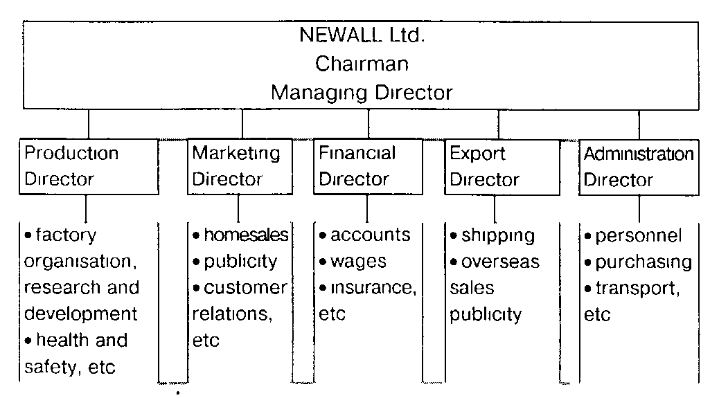

***Unit thirty seven***

**The goods to be bought**

**Text**

The Production Director showed Mr. Smirnov round the factory and answered a lot of questions of his. There were especially many questions asked on the production floor. The Production Di­rector told Mr. Smirnov about the products of the company. Mr. Smirnov was greatly impressed by the number of the new products and by their sophistication. Then the Production Director showed Mr. Smirnov the different departments of the company and introduced him to the management team. When all was seen and spoken of the Production Director took Mr. Smirnov to Mr. Freiser's office.

*Frank:* And what do you think of all that you've seen?

*Ivan:* Oh, it's very interesting and impressive. It's a very good set-up: modern factory, good labour force.

*Frank:* That's true. We have been in this business for over ten years. Besides we are planning to expand. Our annual turnover is about twenty million pounds.

*Ivan:* Then our business will be too small for you, I'm afraid.

*Frank:* You are wrong here, I'm sure. We try to satisfy all our customers. And we treat them all with high esteem.

*Ivan:* By the way, could I have some material on your prod­ucts? I should study the assortment you offer before we discuss other matters relating to the enquiry, or to our future contract.

*Frank:* Naturally you will have all the publicity brochures and leaflets. They contain all the technical details. We have prepared a pack for you. *Ivan:* Thank you very much. That's very considerate of you.

*Frank:* And when will you be able to tell us what devices ex­actly interest you?

*Ivan:* Most probably I'll look through all the materials tonight, then contact our General Director and tomorrow I'll give you our reply.

*Frank:* Hard work, isn't it? But certainly it's better to discuss all the details while you are here in London. Now let's make a break and enjoy lunch at the restaurant just across the street.

***Unit thirty eight***

**Ordering the devices**

**Text**

After Ivan Smirnov had a fact-finding visit to Newall Ltd. *he* studied the materials he got and reported the results of his visit and survey to the General Director. In the morning he tele­phoned Mr. Freiser and made an appointment for 11 a. m. the same day. Thus they met at Mr. Freiser's premises at 11 and after some preliminaries they got down to business.

*Frank:* Judging by your early call this morning you have brought us good news, havent'you?

*Ivan :* That's true. Last night I spoke with my General Director and he gave me the go-ahead to the purchase. And here is the list of the devices we are interested in.

*Frank:* And how many devices of each type are you ordering?

*Ivan : 5* of each the five types, or 25 all in all.

*Frank:* It is rather disappointing, I should say.

*Ivan :* I agree with you here. It's a rather small order. But it's a trial order. If our customers are satisfied with the devices they will order some more. Meanwhile we'll contact our customers in a few other cities in Russia. They might be interested too.

*Frank:* And speaking about your trial order, when do you need the devices?

*Ivan:* Can you deliver them next month?

*Frank:* At the earliest we can deliver them during the second half of the month. And how do you want us to ship the goods?

*Ivan:* By air, this time. They are not very heavy and besides our customers are impatient to test them as soon as possible.

*Frank:* If I understand you properly you would like us to ship them on cif terms by plane. The cif prices will be much higher than the basic prices stated in our bro­chures.

*Ivan:* Then let's discuss the price now.

*Frank:* Shall we have some coffee or tea first?

*Ivan:* I don't mind a break at all.

***Unit thirty nine***

**Prices**

**Text**

**A** fter a coffee break the businessmen resumed their talk:

*Ivan:* And now comes the price problem.

*Frank:* As far as I understand you want us to pay airfreight and insure the devices during their shipment.

*Ivan:* For our trial order these terms are preferable for us. Could you give me your idea of the cif price for each of the devices then?

*Frank:* Before the break I made some calculations and asked the secretary to type the price list on this basis.

*Ivan:* Very good.

*Frank:* Oh, here it is ... Thank you, Nancy.... Now, Mr. Smirnov, you may have a look at the prices. The total sum is three thousand pounds.

*Ivan:* I certainly admit it's a small order. Therefore I shall not mention discounts you usually grant us. But don't take it as a precedent. When we make contracts in future we hope we shall have a certain discount off prices. *Frank:* We shall certainly discuss this matter in every particu­lar case. If you mention future contracts there is a question I would like to ask you. Will you always pre­fer cif prices and shipment by plane?

*Ivan:* Oh, no. Far from it. Only in this particular case we have chosen shipment by plane and cif terms. But in future, if nothing extraordinary happens, we shall practice fob Tilbury terms, as usual.

*Frank:* Fine. No objections on our part. Shall we have a stan­dard contract for your trial order? Ivan: I suppose so. If you can have it prepared now it would be splendid. I'll sign it. I have the power of attorney.

*Frank:* And what would you say if I propose to sign it in the evening before our dinner. We could have dinner at the restaurant of your choice.

*Ivan:* OK. There is a good cosy restaurant near the hotel. It's called White and Red Roses.

*Frank:* Fine. I'll be waiting for you in the lobby at seven p. m.

*Ivan:* See you at seven then. Goodbye.

***Unit forty***

**Contracts in foreign trade**

**Text**

*Here is a part of the Contract Mr. Freiser handed over to Mr. Smirnov in the evening:*

