Evaluation and characterization of CuAlNi single crystals for the conception of an artificial muscle

Project technical report

Prepared for:

VICTHOM BIONIQUE HUMAINE

4913, rue Lionel-Groulx, bureau 33

Saint-Augustin-de-Desmaures

(Québec) G3A 1V1
Canada

INTRODUCTION

Shape memory alloys (SMAs) have been widely investigated as actuators for various applications (robotics…). NiTi has been the most studied SMA, due to its good mechanical performances and biocompatibility. However, when thinking to external limb prosthesis, this material presents several drawbacks, as it’s relatively low response time.

The possibility to produce CuAlNi single crystals in industrializable quantities opened a new area of research for this application. CuAlNi single crystals show higher mechanical and response properties than NiTi, and are so expected to present a better actuation capacity.
Already used as actuators in robotics, CuAlNi elements with a reversible strain between 8 and 10 % and a generated stress of 2 MPa/°C could be used as an actuation system working in torsion, tension, compression or bending mode.

We have proposed, in the experimental protocol “Characterization of CuAlNi single crystals for use as artificial muscle”, studying the actuation behavior of these materials produced in St Petersbourg by the company Memory Crystals Group with the following objectives:

i) To interpret the performance requirements to SM copper single crystal material for prosthesis application
ii) To optimize the alloy composition for maximal efficiency
iii) To study the shape memory behaviour and to test the mechanical and actuation properties of SM copper-base single crystal material
iv) To evaluate the extent influence of the thermal characteristics on the performance of these materials

In this report, we will present results of experimental tests performed at St Petersbourg STU and Ecole Polytechnique Montreal. Then we will evaluate correlations between testings, in order to answer the objectives described in the experimental protocol.

Physical and chemical characterisctics

By physical and chemical characterisctics, we mean the chemical composition of the material we test and it’s density.

2-2 Density measurements:

Density ρ (in kg/m³) of the single crystal alloy is determined by the technology of hydrostatic weighting.

2-2-1 Testing

Five specimens have been weighted in atmosphere and butanol. The density is defined by equation:
$$ρ_{\text{sample}}=\frac{m_{1}}{(m_{1}−m_{2})}(ρ_{2}−ρ_{1})+ρ_{1}$$
Where:
ρ₁ = 0.0012*10³ [kg/m³] is the atmosphere density,
ρ₂ = 0.8106*10³ [kg/m³] is the butanol density at testing temperature (18⁰C);
m₁ is the specimen’s weight in atmosphere;
m₂ is the specimen’s weight in butanol with taking into account of weight (m”₂) of partly put wire into butanol. The wire is connected with specimen.
Therefore m₂ = m’₂ - m”₂ ,
Where:
m’₂ is the specimen’s weight in butanol including weight of wire.
m”₂ is the wire’s weight partly put to butanol.

2-2-2 Experimental results

Data of weights and density are included to Table 1.
Table #1

# sample | m₁  [kg] | m’₂  [kg] | m”₂  [kg] | m₂  [kg] | m₁ - m₂  [kg] | ρ  [kg/m³]
1 | 0.9779*10⁻³ | 0.88525*10⁻³ | 0.0175*10⁻³ | 0.86775*10⁻³ | 0.11015*10⁻³ | 7.187*10³
2 | 0.9833*10⁻³ | 0.8899*10⁻³ | 0.0175*10⁻³ | 0.8724*10⁻³ | 0.1109*10⁻³ | 7.178*10³
3 | 0.9960*10⁻³ | 0.9013*10⁻³ | 0.0175*10⁻³ | 0.8838*10⁻³ | 0.1122*10⁻³ | 7.186*10³
4 | 0.9839*10⁻³ | 0.8905*10⁻³ | 0.0175*10⁻³ | 0.8730*10⁻³ | 0.1109*10⁻³ | 7.182*10³
5 | 0.9831*10⁻³ | 0.8898*10⁻³ | 0.0175*10⁻³ | 0.8723*10⁻³ | 0.1108*10⁻³ | 7.183*10³
With: ρ1=1,2, ρ 2= 810,6

Table 1: Density results on CuAlNi single crystals

Result Data:
Average density of CuAlNi alloy is ρ_{CuAlNi} = 7183,2 kg/m³ .
Standard deviation=3,2

2-2-3 Comments

These results agree with our expectations; according to the density of each chemical elements which the alloy is made of:
- Cu: d= 8920 Kg/m³
- Al: d= 2700 Kg/m³
- Ni: d= 8908 Kg/m³

Thus, results are very reproducible; this is due to the high accuracy of this measurement technique and reveals the high homogeneity of the material produced.

Shape memory characteristics

In this part, we first determine transformation temperatures by DSC; then we evaluate other characteristics of the shape memory behavior (active strain, transformation plasticity strain and transformation hysteresis) as described in the protocol.
The stability of these characteristics during thermo-cycles is also evaluated, because it is a main issue of these materials.

3-1- Phase transition temperatures

3-1-1 Objective

The shape memory behavior arises from martensite – austenite transformation of the alloy. Four characteristic temperatures, Mf, Ms, As, Af are related to this transformation; they are determined by DSC.
Corresponding to the specifications, a maximum temperature for this application is fixed to 120°C.
First of all, as it is known that characteristic temperatures highly depend on the mechanical state of the material (stressed or not), CuAlNi single crystals have been produced to exhibit characteristic temperatures much lower than the 120°C limit.
Then, the specific heat capacity (Cp) of the material will also be determined in this testing, as it is a characteristic of interest for modeling.

Finally, transition temperatures under stress and consequently, the temperature range for this application will be determined in the shape memory behavior characterization (step 3-2).

3-1-2 DSC testing (St Petersbourg and Montreal)

DSC testings have been performed in St Petersbourg for non stabilized samples and in Montreal for stabilized samples in the following conditions:
- Calibration of the apparatus with reference samples, in nitrogen atmosphere.
- Placing sample and inert reference capsules
- Running heating and cooling thermal cycle between 0°C and 100°C at 10°C/min
- Determination of Ms, Mf, As, Af, as described in the ASTM norm: F 2004-00

Parameters of these tests are more precisely described in the procedures “DSC testing on single crystals at St petersbourg” and “DSC testing on single crystals at Montreal”.

3-1-3 Experimental results

3-1-3-1 Non-stabilized 3mm diameter samples

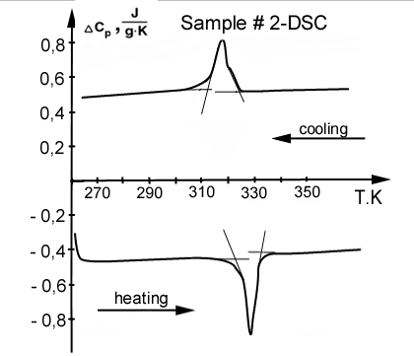

Curve 1: DSC results on 3 mm diameter Cu-Al-Ni single crystals, before stabilization (Specimen 2).
To my knowledge, Cp is an intrinsic characteristic of any material’s structure. It is defined by the equation: dH = n Cp dT.
In these conditions, the behavior described in Curve 1 couldn’t be dCp=f (T).
Maybe it is dH = f (dT). In these conditions, we could determine Cp of austenite and martensite structure (the area under the transformation curve).
What is your opinion about this. Please inform us if your software allows determination of Cp.

Temperature °C (K) | Ms | Mf | As | Af | Cp of martensite structure | Cp of austenite structure
Sample 1 | +50 (323) | +36 (309) | +46 (319) | +57 (330)
Sample 2 | +52 (325) | +38 (311) | +48 (321) | +59 (332)
Sample 3 | +53 (326) | +40 (313) | +52 (325) | +62 (335)
Sample 4
Average value | 51.7 | 38 | 48.7 | 59,3
Standard deviation
Table 2: Cu-Al-Ni single crystals, diameter 3 mm, before stabilization.

3-1-4 Comments

3-2 Shape memory behaviour and functional properties (St Petersbourg)

3-2-1 Active strain

3-2-1-1 Objectives:

Active strain is the sum of the shape memory strain and irreversible strain. (See protocol point 5.1.2.1)
This testing aims to determine stresses values that correspond to large strains (i.e: largest strains with lowest stress applied).

3-2-1-2 Testing

This testing has been performed in two parts, corresponding to the protocol’s description:

Step 1) Determination of a range of maximum shape memory strain

- Samples are elongated up to different predetermined active strains by Instron apparatus,
- After removing the stress, the material is heated in free-stress conditions, up to 120°C, by original special setup.
- The strain-temperature behavior is observed and plotted, in order to determine the proportion of shape memory strain and irreversible strain
- This testing is performed for active strains between 4 and 9%

Step 2) Determination of the corresponding minimal applicable stress range.

- Samples are submitted to a constant applied stress by original special setup
- Heating is performed under stress.
- The strain-temperature behavior is observed and plotted, in order to determine the proportion of shape memory strain and irreversible strain
- This testing is performed for stresses of 50, 100, 150 MPa

3-2-1-3 Experimental results:

To be completed

3-2-2 Transformation plasticity strain and Transformation hysteresis

3-2-2-1 Objectives:

As explained above, transformation temperatures increase with the stress applied. It is important to characterize this transformation temperatures shift, in order to be conform to the temperature specifications.
In this part of testing, different stress will be applied, in order to obtain the maximum strain level at heating (determined in step 1), without going out of the allowed stresses range (limiting transformation to temperatures under 120°C).

Also, during the cooling step of a thermocycle, the total accumulated strain (transformation plasticity strain) is expected to be different to that at heating; the material is said to exhibit a transformation hysteresis.
This characteristic will be determined for each thermocycle performed.

3-2-2-2 Testing

To be completed

3-2-2-3 Experimental results

To be completed

3-2-2-4 Comments

To be completed

3-2-3 Stability of transformation temperatures

3-2-3-1Objectives

Transition temperatures and mechanical behavior of the material are expected to vary during the first thermo-mechanical cycles and then to stabilize after several cycles.
In this part, the number of cycles after which the materials behavior is stabilized is determined.
Then, each of the characteristics described in point 3-2-2 has been determined and compared to the non-stabilized material.

3-2-3-2 Testing

For this test, optimal conditions defined in step 3-2-2 have been used to perform a few thermocycles in the same conditions.

3-2-3-3 Comments

To be completed

Mechanical Behaviour

4-1 Objectives:

The response of SMA is highly dependent on temperatures and state phases. SMA may have three typical mechanical behaviours depending on the testing temperature (see figure 9i of the protocol).
The aim of this part of testing is to determine properties of CuAlNi single crystals under tensile stress at different constant temperatures, and to compare the actuation capacity before and after the material’s stabilization.
For this application, main interest is in the material’s behaviour at θ₁. Non-stabilized (part I) and stabilized (part II) samples will be tested at this temperature.
However, as the material is heated while used in applications, it is important to know it’s behavior at different temperatures (θ₂, θ₃, θ₄); this has been performed in part I only.

4-2 Testing equipment:

All mechanical tests were performed on an MTS™ 858 Bionix Test System servo-hydraulic load frame equipped with an environmental chamber. The chamber’s temperature is measured and controlled from the middle of the specimen, using a K-type thermocouple held in contact with the specimen and mounted with a thermally conductive paste (Aluminium) to ensure good heat transfer qualities between the specimen and thermocouple.

4-3 Measurements and calculations:

Fourteen preliminary tests have been performed, in order to determine optimum testing parameters and a methodology for the measurement of stresses, strains and temperatures.

4-3-1 Stresses measurement

The adequate force cartridges corresponding to force measurements in each test have been determined in preliminary tests. They are listed in worksheets (see procedure “tensile testings on CuAlNi single crystals”).
Corresponding stresses are calculated from the measured force, as described in the protocol.

4-3-2 Strains measurement

In our device, strains can be determined following two ways:

- Direct measurement of the extensometer value
- From the measurement of crosshead displacement, and calculation, using the formula: ε=ΔL/L0 (see protocol).

Results of preliminary tests, up to 10% strain, demonstrates the following results:
      - Strains determined by the extensometer and strains calculated from the cross section displacement are very close one to another;
      - For large strains (above 10%), the use of an extensometer is needed to withdraw the threads plastic deformation effects and to determine the real strain of the material.

So, on one side, as the strain value is very important for ambient temperature tests; it has been measured using an extensometer.
On the other side, for testing at non-ambient temperatures, the cross section displacement has been used for strains determination.

The maximal recoverable strain has been determined as follows:
ε_{sm}= ε_{a} - ε_{ir}, where ε_{a} is the residual strain after stress unload (at θ₁) and ε_{ir} the residual strain after further heating (up to 120°C).

4-3-3 Temperatures measurement

Here are the temperature conditions determined during preliminary tests:
      - For testing at non-ambient temperature, heating ramps of 10 minutes up to the predetermined temperature have to be performed.
      - For generated stress and strain recovering measurements, the temperature will be directly set to the desired value, so as heating to be performed as fast as possible.
      - Cooling stages have to be performed by opening the chamber’s door.
      - A five minutes temperature plateau allows good stabilization of the whole material’s temperature.

These conditions correspond to a highly conductive material.

4-4 Test conditions

Part I:
As described in the protocol, testing temperatures have been chosen based on DSC testing at St Petersbourg; they are:
      - θ₁= Αmbient temperature (≅20°C)
      - θ₂=65°C,
      - θ₃=90°C,
      - θ₄=120°C.

Mechanical loading and unloading were performed in displacement control at two constant strain rates determined corresponding to the protocol as:
      - 1%/min (comparative strain rate)
      - 10%/sec (strain rate corresponding to the application).

Part II:
Mechanical loading and unloading were performed in the same conditions as in the shape memory behavior test, at temperature θ_{1,} in part I.

4-5 Results before stabilization

4-5-1 General behavior of the material at ambient temperature (Series A and F):

4-5-1-1 Test conditions

At temperature θ1, 3 tests up to the material’s fracture have been performed, in order to determine the general behavior of the material and the maximum strain of interest at loading. (See procedure “Mechanical testing of single crystals”)

4-5-1-2 Experimental results

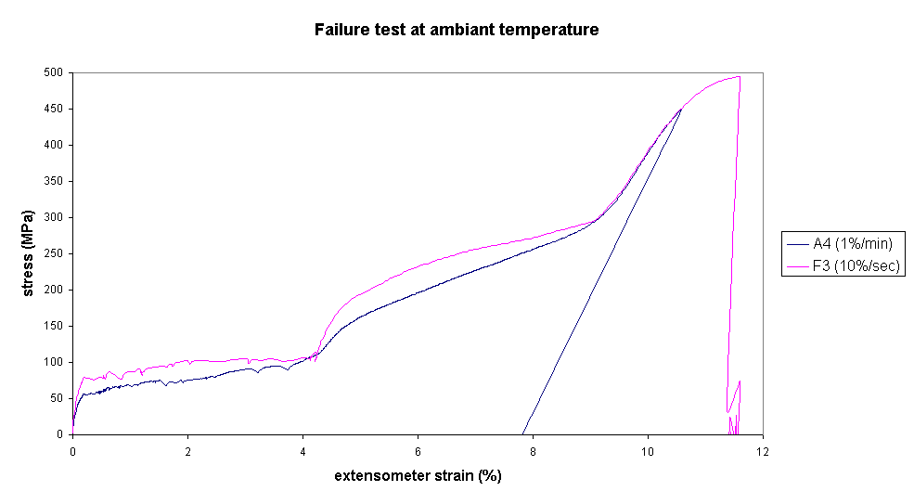
II
III
IV
I
V

Τ=θ1  Up to failure | σ_{ys}:Yield stress (Mpa) | ε_{max}: Failure Strain (%) | σ_{max}: Failure Stress (Mpa)

Series A (1%/min)
A1 | 67.78
A2 | 59.41 | 11.04 | 476.10
A3 | 62.07 | 10.60 | 451.30
Average value | 63.09 | 10.82 | 463.70
Standard deviation | 3.49 | 0.22 | 12.40

Series F (10%/sec)
F1 | 65.09 | 11.26 | 490.68
F2 | 81.65 | 12.28 | 468.23
F3 | 75.05 | 11.59 | 494.48
F4 | 66.22 | 11.28 | 469.53
Average value | 72.00 | 11.60 | 480.73
Standard deviation | 6.77 | 0.41 | 11.93

4-5-1-3 Comments

Results of this test are relative to the martensitic phase, which is the only stable phase at this temperature.

General behavior of the material:
Based on the stress-strain curve, the behavior of these alloys, at loading, can be divided in five different parts (see curve :), up to the material’s failure (at around 475 Mpa stress and 10,5 to 11,5 % strain):

I: Elastic behavior of the material (up to 0,2% strain);
II: A first stress plateau (up to approximately 4.5% strain); it connects with reorientation of favorable martensitic boundaries without increase of stress (near 65Mpa);
III: Increase of stress marks the starting of reorientation of unfavorable boundaries (up to approximately 8,5% strain);
IV: A second elastic part, at strains above 8.5% (fourth part), shows an important increase of stress;
V: Just before failure, a plastic strain plateau (at strains above 10,5 %) is seen; this plateau shows the beginning of plastic deformation and non-recoverable strains.

During experiments, it has been noticed that the material’s fracture always occurred in the threads section. At the beginning of plastic deformation, stress concentration occurs at the threaded ends and the material fails near the clamps.
However, we voluntary chose to test non dumb-bell shaped materials because we were only interested in determining the shape memory behavior of these materials. In order to be able to characterize the entire stress-stain curve, up to fracture, dumb-bell shaped samples should have been used.

Maximum strain at loading:
Based on the information provided by this test, strain levels at loading have to be chosen in the second elastic part of the stress-strain curve (between 8,5 and 10,5%). This way ensures, the entire shape memory strain can be measured.
For testing the shape memory behavior (following test), we therefore chose to load the samples up to 10 %. Possible remaining deformation after heating would give us the information that the material has been plastically deformed.

From the reproducibility point of view, these results are satisfactory.
Even though the material’s fracture is generally higher in tests at high strain rates, it is however impossible to conclude about any behavior concerning this because these values are strongly related to the material, its threads and the way it has been clamped for testing.

4-5-2 Shape memory strain (Series B and G)

4-5-2-1 Testing conditions:

For each of the two characterized strain rates, four samples have been tested in the following conditions:
      - At temperature θ1, the sample has been loaded up to 10% strain, and unloaded up to zero stress;
      - After unload, the inferior clamp was detached and the sample’s heated (up to 120°C).
      - After return to ambient temperature, the recovered strain was measured by the extensometer;
      - A second load-unload testing up to 10% strain have then been performed (on the same sample);
      - The sample was heated (up to 120°C), while keeping the material clamped
      - The maximum stress generated at heating has been then measured.

More explanations about these testing conditions are written in the procedure “Mechanical testing of single crystals”.

4-5-2-2 Experimental results

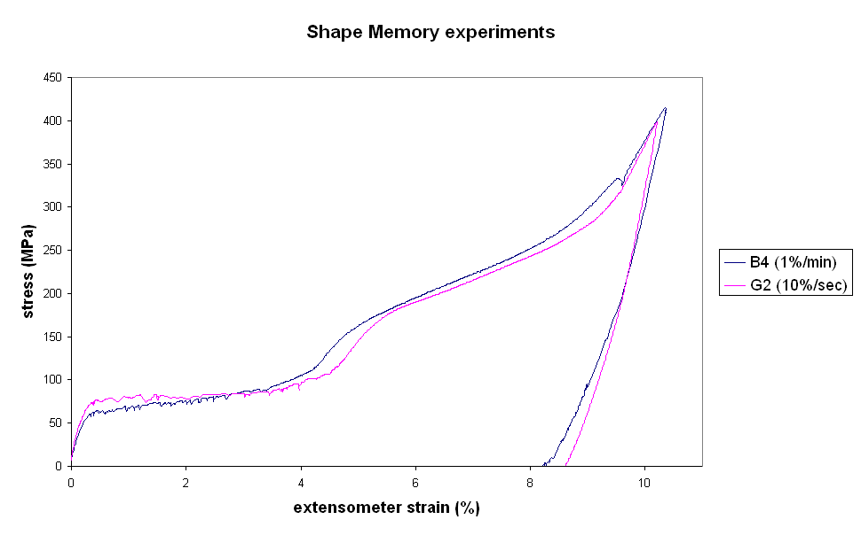
Τ=θ1, Shape memory strain | E : Young Modulus (Gpa) | σ_{ys}:Yield stress (Mpa) | ε_{sm} : shape memory Strain (%) | Irreversible Strain  (ε_{a}) | σ_{sm:} Generated  Stress (MPa)

Series B
B1 | 22.91 | 66.40 | 7.84 | 0.11 | 126.5
B2 | 26.87 | 66.39 | 8.38 | 0.01 | 132.3
B3 | 22.12 | 58.82 | 8.24 | 0.21 | /
B4 | 25.71 | 62.10 | 8.20 | 0.13 | 133
Mean data | 24.40 | 63.43 | 8.17 | 0.11 | 130.60
Standard deviation | 1.95 | 3.19 | 0.20 | 0.07 | 2.91

Series G
G1 | 32.92 | 75.91 | 8.57 | -0.25 | 132
G2 | 27.67 | 75.14 | 8.61 | 0 | 132.6
G3 | 31.28 | 70.90 | 8.43 | -0.06 | 140
G4 | 28.32 | 61.80 | 8.28 | 0.03 | /
Mean data | 30.05 | 70.09 | 8.47 | -0.07 | 134.87
Standard deviation | 2.14 | 5.61 | 0.13 | 0.11 | 3.64

4-5-2-3 Comments

General behavior:
As well as in the precedent test (step 4-5-1), results of this test relates the martensitic phase’s behavior, which is the only stable phase at ambient temperature. The behavior described in 4-2-2-3 is the same during loading up to 10%.
After unloading, a potential actuation strain, between 8,2 and 8,5% is displayed and it is important to notice that only this non-elastic part generates force for actuation.
The 10% strain obtained at loading also includes the sum of two elastic deformations of the sample, induced during loading.

Maximum shape memory strain:
Each sample tested exhibits between -0,25% and 0,2% strain after heating. These values are due to a strong dependence of our measurement on the sample’s shape and eventual slight extensometer slipping during heating.
In these conditions, shape memory strain results obtained after heating the samples demonstrate the great capacity of the material to recover between 8,2% and 8,5% strain. Thus, it can be considered that these single crystals exhibit a virtually null irreversible deformation. This is a very promising result, which might be confirmed after several working cycles, in further fatigue tests.

Maximum generated stress:
The generated stress, which can be delivered by these alloys, is one of the most important paramaters for this application.
Generated stress values were found maximal at the maximum temperature of heating (120°C). Higher generated stresses could have been measured if the material had been heated above this temperature; however, as this case doesn’t correspond to our application, it hasn’t been tested.
All generated stresses measured are comprised between 126MPa and 140Mpa, and a good reproducibility of results has been seen.

Young modulus and yield stress of martensite:
The Young modulus of martensite is an intrinsic parameter of the material. It can be obtained from the first elastic domain of the loading curve (see protocol).
Statistical results leads to a Young modulus of 24GPa for samples tested at 1%/min, and 30 Gpa for those tested at 10%/sec.
These differences could be due to the material’s martensite structure, which can vary between samples, but also to the some measurement difficulties. Indeed, on curves provided by this test, it has been found difficult to plot a tangent to measure the Young Modulus with high reproducibility, because the elastic part of the martensite structure is very short.

The same tendency is also observed for yield stress values, which are a bit higher at higher strain rates (63,4MPa and 70,1MPa, respectively for series B and G). But reasons for this non-intrinsic parameter may be different. In this case, results reflect the generally harder behavior of materials, when submitted at higher strain rates.

These two tests (steps 4-5-1 and 4-5-2) allows us to understand how is the material reacting when submitted at temperatures under Ms. Determination of the characteristics of the alloy at temperatures above Af, will help us understanding the behavior of the material at heating.

4-5-3 Test at temperature θ₂ Series (C and I)

4-5-3-1 Testing conditions

Even though, at temperatures above Af, the elastic behavior of these materials is the only part of interest for this application, it has been chosen to follow the test at higher strains. By this way, we have a more comprehensive knowledge of these alloys pseudoelastic behavior, which could maybe help understanding actuation behavior.
In these conditions, loading levels have been determined (in preliminary tests) as the values of the beginning of a second elastic part in the stress-strain curve.
At temperature θ2, four load-unload testing have been performed, up to 8% strain at 1%/min strain rate and up to 9% strain at 10%/sec strain rate.

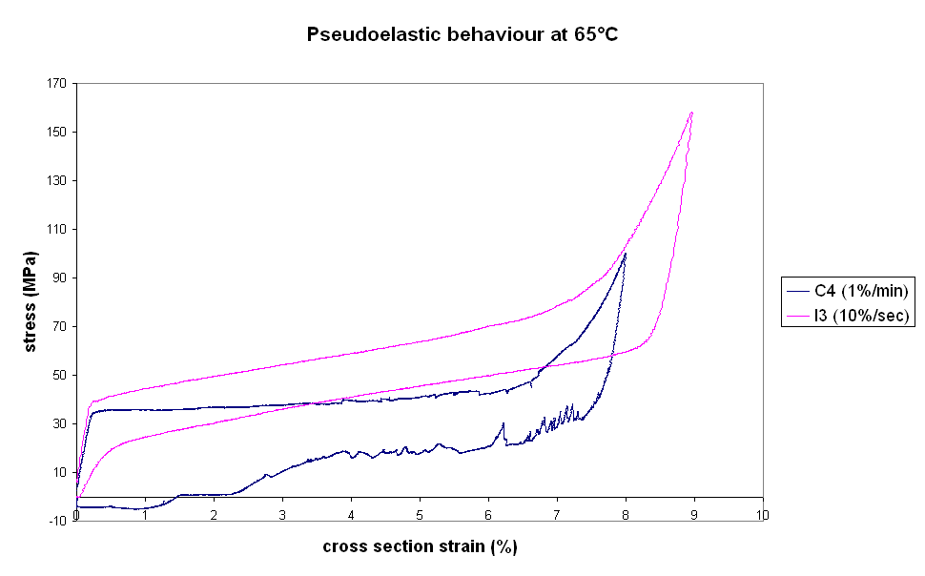
4-5-3-2 Experimental results

T = 65°C | E : Young Modulus (Gpa) | σ_{ys}: Yield stress at loading (Mpa) | Strain after unload at  σ = 0

Series C
C1 | 16.80 | 30.75 | 1.53
C2 | 15.50 | 30.50 | 2.65
C3 | 16.81 | 39.50 | 2.36
C4 | 13.86 | 35.98 | 1.46
Average | 15.74 | 34.18 | 2.00
Standard deviation | 1.21 | 3.77 | 0.52

Series I
I1 | 17.17 | 38.16 | 0.16
I2 | 16.02 | 39.53 | 0.10
I3 | 17.02 | 41.24 | 0.05
I4 | 16.74 | 39.79 | 0.08
Average | 16.74 | 39.68 | 0.10
Standard deviation | 0.44 | 1.09 | 0.04

4-5-3-3 Comments

Results of this test are relative to a pseudoelastic behavior of the material (just above Af).
Even if samples tested at lower strain rates show a shorter pseudoelastic strain; a good reproducibility of results can be seen in these experimental conditions.

General pseudoelastic behavior:

Curves obtained show general behaviors that can be divided in three parts:

      - In the first part of these two curves, stresses increase rapidly with strain, up to around 0,2%; this domain corresponds to the elastic deformation of the austenitic phase;
      - A stress plateau, relative to the beginning of the stress induced martensite formation, follows it.
      - The third part of the loading phase is a second elastic deformation of the marterial. In this part stress increases quickly with strain.

Even though unloading curves present the same behaviors as at loading, a stress hysteresis appears. It is due to the martensite-austenite transformation, which doesn’t occur at the same stress level under a loading or unloading process.

Another important point to notice is that, at high strain rate, samples recover nearly all their initial shape, while it is not the case at low strain rate, where an important strain remains after unloading (around 2%).
In order to retransform to austenite, the detwinned martensite phase must have enough energy to return to its previewed configuration (twinned). At 65°C, the thermal energy seems not to be sufficient for this reconfiguration, and the material do not recover it’s original shape for low strain rates. However, at higher strain rates, the kinetic energy delivered seems to help it to recover its initial shape. This assertion remains to be confirmed by tests at different strain rates as well as a thermodynamic study of the martensite-austenite transformation.

Young modulus and yield stress at θ₂:
The Young modulus of austenite (16-17 Gpa) is smaller than for the martensite (between 25 and 30 Gpa). This result confirms that the elastic behavior of martensite is generally very hard.
At this temperature (very close to Af), the martensite phase appears for small applied stresses; The stress plateau of the material begins around 35-40 Mpa (yield stress), at loading.

A really horizontal loading plateau is observed at low strain rates, whereas it slowly increases with strain at high strain rates. One possible reason for this phenomenon is that, at high strain rates, the material does not have sufficient time (and energy) to accommodate the deformation, by forming enough martensite and consequently, it exhibits both pure martensite and pure austenitic behavior. At lower strain rates, the material is able to form enough stress-induced martensite that accommodate the deformation, so the plateau really seems horizontal.

4-5-4 Tests at temperature θ3 (Series E and H)

4-5-4-1 Testing conditions

At temperature θ3, four load-unload testing up to 9,5% strain, have been performed, for each strain rate. These parameters have been determined following the same criteria as described in step 4-4-4-1.

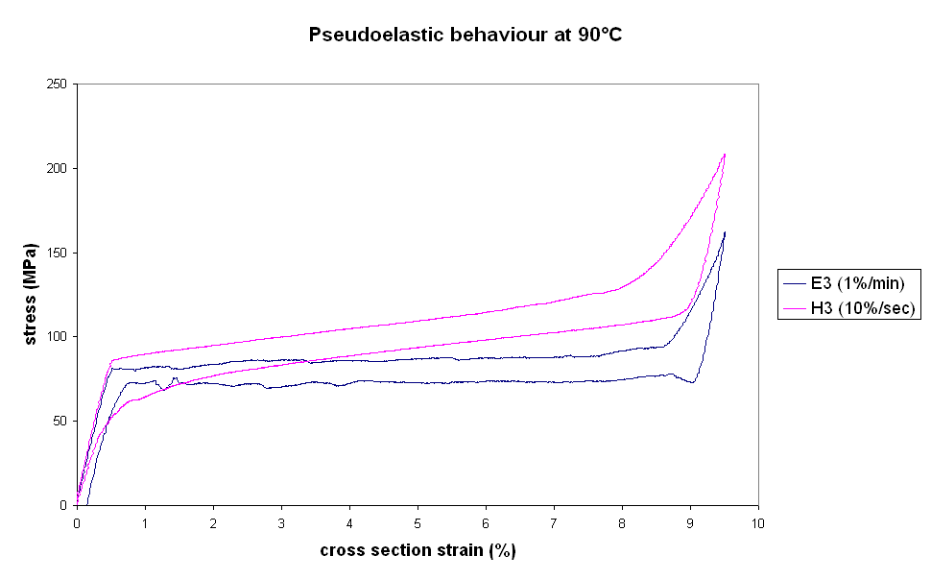
4-5-4-2 Experimental results

T = 90°C | E : Young Modulus (Gpa) | σ_{ys}: Yield stress at loading (Mpa) | Strain after unload at  σ = 0

Series E
E1 | 16.97 | 81.29 | 0.08
E2 | 16.32 | 82.13 | 0.10
E3 | 16.50 | 82.34 | 0.14
E4 | 16.61 | 83.69 | 0.07
Average | 16.60 | 82.36 | 0.10
Standard deviation | 0.24 | 0.86 | 0.03

Series H
H1 | 16.46 | 86.32 | 0
H2 | 17.07 | 87.91 | 0
H3 | 16.95 | 87.08 | 0
H4 | 16.04 | 90.63 | 0
Average | 16.63 | 87.99 | 0
Standard deviation | 0.41 | 1.63 | 0

4-5-4-3 Comments

General behavior:
As well as at θ₂, results at θ₃ are related to the pseudelastic behavior of these materials. Therefore, the same zones as in the previous test are observed on the stress-strain curve, with a good reproducibility.

However, a great improvement of the recovered deformation can be seen. At low strain rate, the residual strain after unloading is very small, and at high strain rate, the material totally recovered its initial shape after unloading. This means the thermal energy provided by the increase of temperature enables friction forces to easily overcome.

Young modulus and yield stress at θ₃:

Both experiments at 10%/sec and 1%/min lead to the same value of young Modulus (i.e., 16.6Gpa). This value also corresponds to the one at θ₂. This is because Young modulus is an intrinsic property of the material and, therefore, it is related to the structure of the material that doesn’t change in this first part of the loading curve.

On the contrary, stress plateau at loading and unloading are much higher than at θ₂. It is the same for the yield stress that is drastically increased (≈85 Mpa).
This observation fits with theoretical previsions and basic knowledge that: The hotter the material is, the more stable the austenite is, and the higher are needed stresses to transform austenite into martensite.

4-5-5 Tests at temperature θ4

4-5-5-1 Testing conditions

At temperature θ4, four load-unload tests, up to 10% strain, have been performed, for each strain rate. These parameters have also been determined following the criteria described in step 4-4-4-1.

4-5-5-2 Experimental results
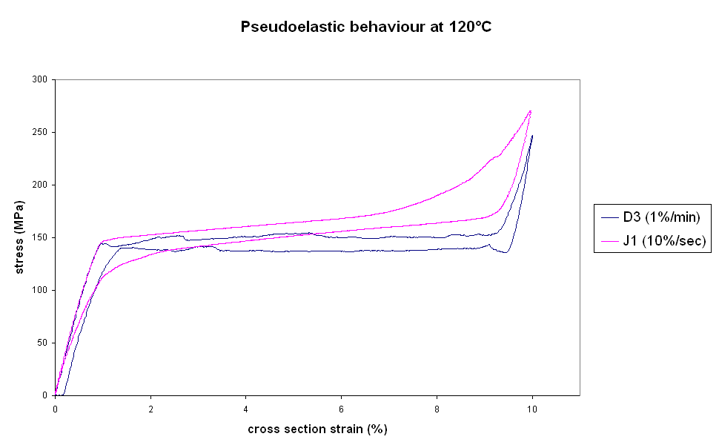
T = 120°C | E : Young Modulus (Gpa) | σ_{ys}: Yield stress at loading (Mpa) | Strain after unload at  σ = 0

Series D
D1 | 16.08 | 152.26 | 0.14
D2 | 16.06 | 146.10 | 0.08
D3 | 16.44 | 143.64 | 0.11
D4 | 16.36 | 152.57 | 0.03
Average | 16.23 | 148.64 | 0.09
Standard deviation | 0.17 | 3.87 | 0.04

Series J
J1 | 15.86 | 149.21 | 0
J2 | 16.40 | 153.24 | 0
J3 | 16.43 | 150.60 | 0
J4 | 15.85 | 146.11 | 0
Average | 16.13 | 149.79 | 0
Standard deviation | 0.28 | 2.57 | 0

4-5-5-2 Comments

At this temperature (i.e: the maximum possible temperature for the prosthesis application), the material still exhibits a pseudoelastic behavior, which confirms θ4 is below Md.

The behaviour displayed in this test is very close to that obtained at 90 degrees:
      - There is no residual strain after unloading at 10%/sec and the same very small 0,1% residual strain at 1%/min strain rate;
      - The Young modulus is still just above 16 Gpa, which confirms the assertion written above.

A considerable increase of the yield stress at loading is seen, due to the elevation of temperature. The range of values for this parameter is now around 143-153Mpa. This result is very important and will be discussed in next point (4.6).

4-6 Discussion of results of part I

Material’s behavior above Af.
The alloy’s behavior above Af has been studied for three different temperatures; a pseudoelastic behavior is seen at each of these temperatures. If results are quite close one to another for the young modulus, in the case of the yield stress a considerable increase with the temperature is observed (see picture below).

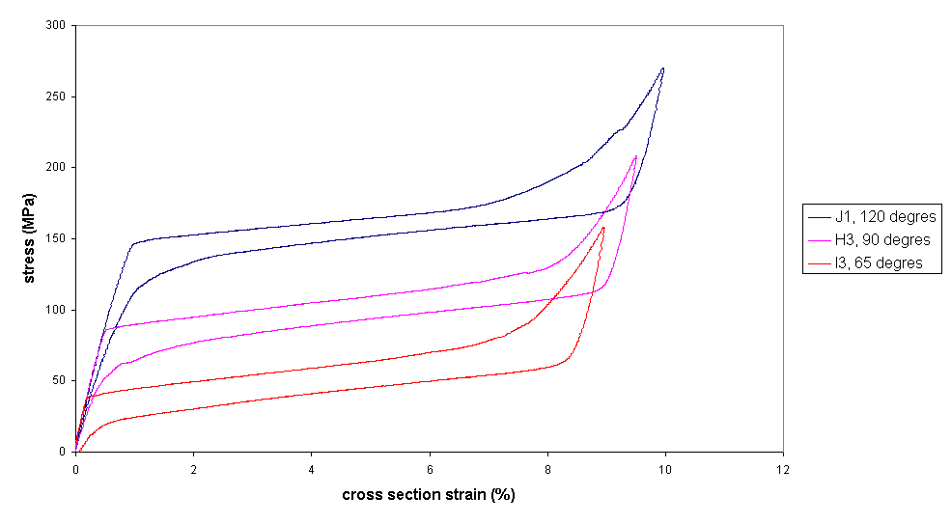
Reduction of the hysteresis with the increase of temperature
Increase of the Yield stress with the increase of temperature
Hysteresis: ~18MPa
Hysteresis: ~16MPa
Hysteresis: ~14MPa

This increasing of the yield stress is due the austenite phase’s stability, which increase with the temperature.
Also observed, is the stress hysteresis decrease while increasing the temperature. This can be explained by the thermal energy available at high temperatures; the structure homogeneity of the entire material is strongly related to this helps the entire material to this energy contribution.
All temperatures between Af and Md should exhibit this kid of behavior and testing of higher temperatures would allow determining Md.

Stress generation vs temperature

The stress generated by the material and the yield stress of the austenite have been found to be very dependent on the temperature. This evolution is displayed in curve..

A linear evolution of these two parameters, as a function of the temperature, can be observed on curve ().The director coefficient of these two function is around 2 Mpa/°C.
In order to recover any deformation, the stress state of the material must be in the elastic domain of the stress-strain curve, at a given temperature.
In these conditions, the stress generation should be limited by the yield stress of the austenite.
This is a very important conclusion, in order to optimize the stress generation of these alloys.

Comparison with young modulus of different materials (to be completed)

Concluding remarks : mechanical behavior of the non stabilized alloy
This alloy present very promising mechanical testing results. High generated stresses (up to 140 MPa), as well as high shape memory strains (up to 8,5%) seem to be available. This may produce much work.
It is necessary to confirm this result and eventual differences on stabilized samples, because only these samples represent the real capacity of the material to be actuated several times in any device. This is the aim of the part II.

4-7 Tensile tests part II

4-7-1 Test conditions

4-7-2 Experimental results

4-7-3 Discussions

V) Influence of Physical and thermal characteristics on the performance of the material

Concluding remarks

perspectives

RECOMMANDATIONS AND PROPOSITIONS

ANNEXES

