DSC curves of the alloy #1

350 400 T,K

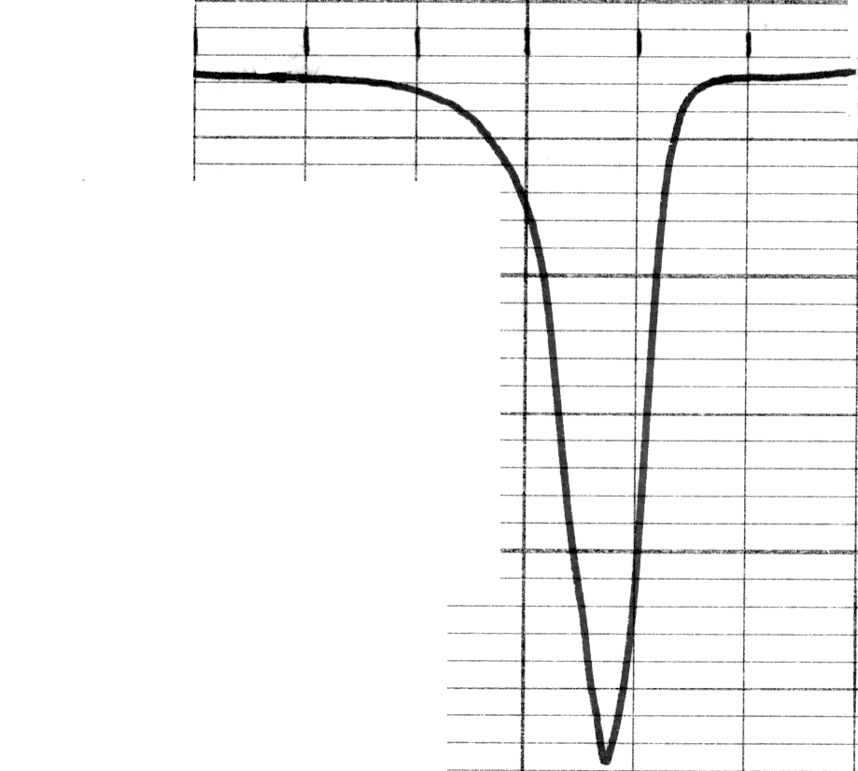
HEATING
0,1 J/(g·K)

Fig.1.a. Samples after quenching and aging during 30 min at 130C .

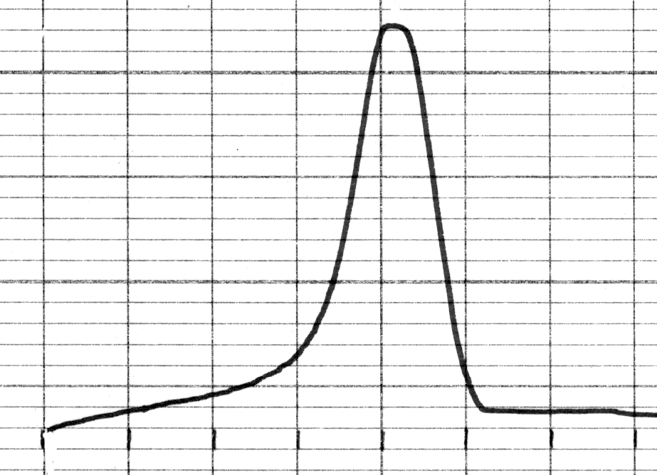
COOLING

350 400 T,K
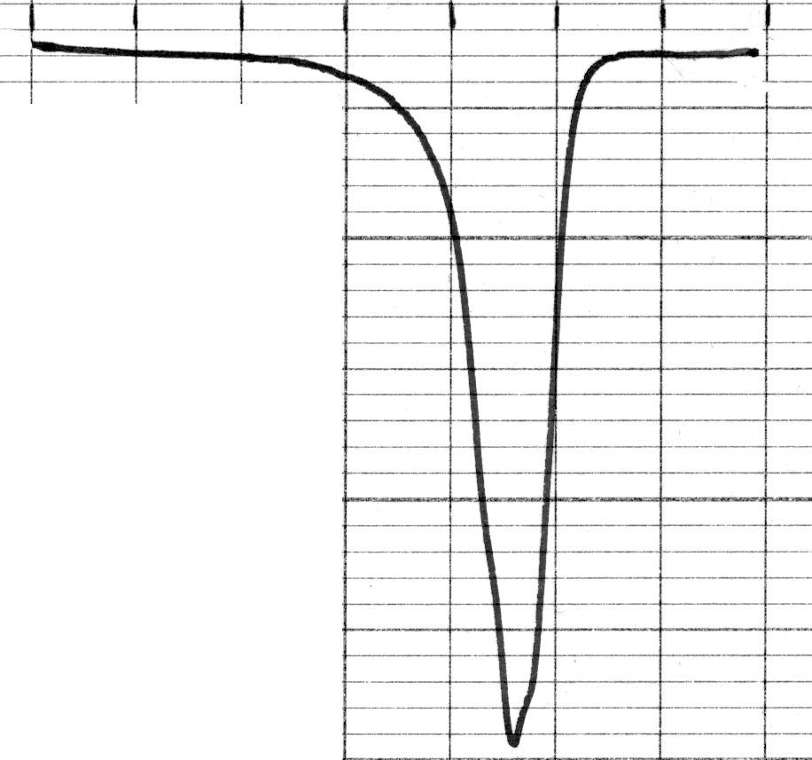
0,1 J/(g·K)

HEATING

Fig.1.b. Thermocycle 1.

