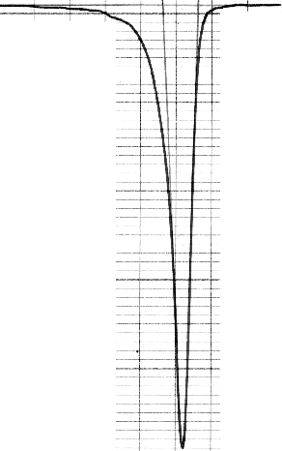

HEATING
0,1 J/(g·K)

DSC curves of sample #3

400 450 T,K

Fig.3 a. Sample #2 after quenching and aging during 60 min at 200C

COOLING
0,1 J/(g·K)

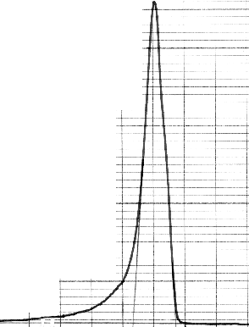
HEATING
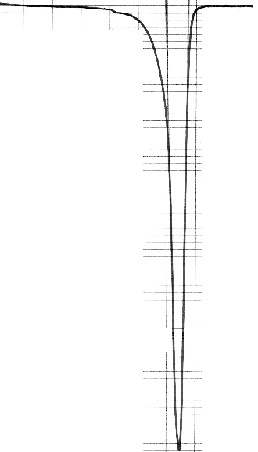
400 450 T,K

Fig.3. b. Thermocycle 1.

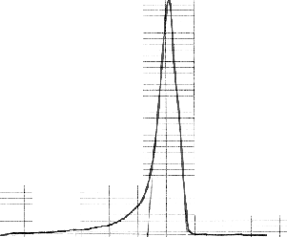
COOLING
0,1 J/(g·K)
400 450 T,K

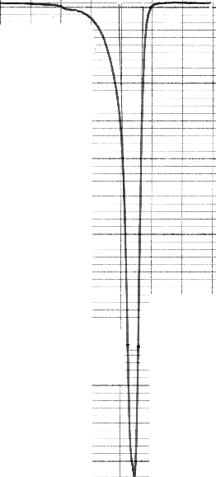
HEATING

Fig.3.c. Thermocycle2.

