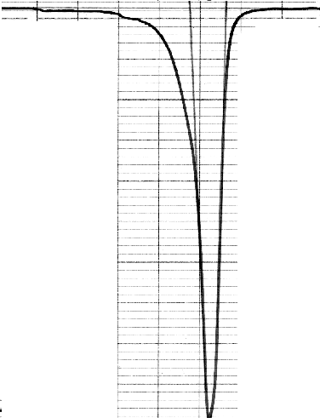
400 450 T,K
HEATING
0,1 J/(g·K)

DSC curves of sample #2

Fig.2.a. Sample #2 after quenching and aging during 30 min at 200C .

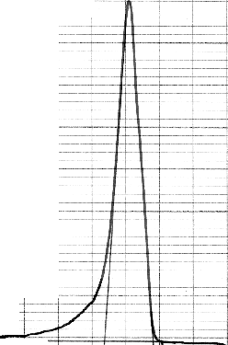
COOLING
0,1 J/(g·K)

400 450 T,K
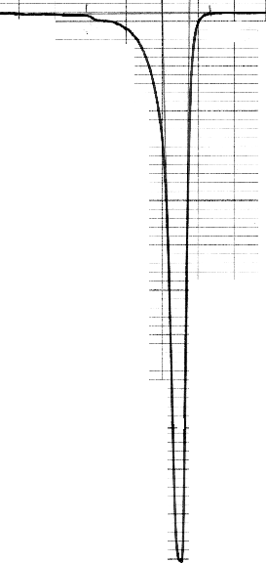
HEATING

Fig.2.b. Thermocycle 1.

COOLING
0,1 J/(g·K)

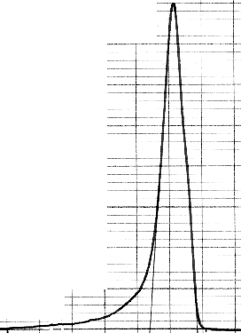
HEATING
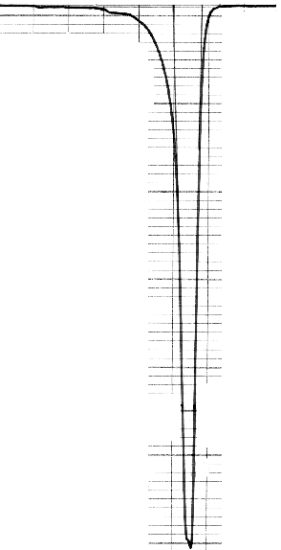
400 450 T,K

Fig.2.c. Thermocycle 2.

