DSC curves of sample #1

400 450 T,K

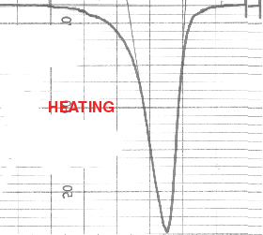
0,1 J/(g·K)

Fig.1.a. Sample #1 after quenching.

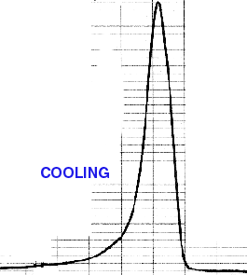
0,1 J/(g·K)

400 450 T, K

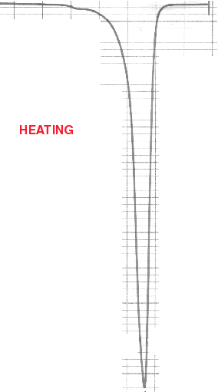

Fig.1.b. Thermocycle 1.

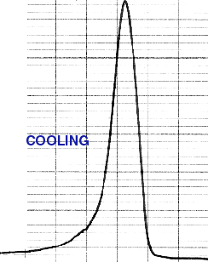
0,1 J/(g·K)
400 450 T,K
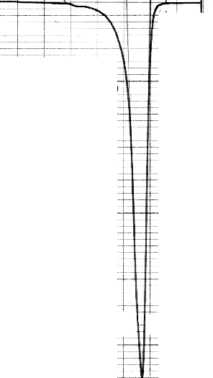
HEATING

Fig.1.c. Thermocycle 2.

